Chapter 7, Solution 1.

- τ=RC = 1/200
For the resistor, V=iR= 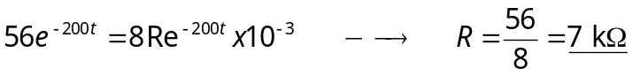
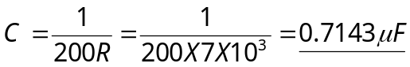

- τ =1/200= 5 ms
(c) If value of the voltage at = 0 is 56 .

